# Embedded Systems – Term Project

## Paige Gruber & Johnnie Zaharia

### Dinosaur Jump Game

#### Requirements

Inputs

* Buttons RB0, RB1

Outputs

* LCD Display
* 8 Ohm Speaker

Relationships

* First round starts automatically. Start tracking play-time when game starts.
* LCD Display shows player avatar (simple dinosaur) on lower left side of the screen.
* Randomly generated cacti scroll across the screen from right to left (toward player/dinosaur).
  + Prevent one cactus immediately after another (at least 1 space between each cactus)
  + After 3 seconds, scroll speed gradually increases
* Player jumps by pressing RB1, with the goal of jumping over every cactus.
  + Note C5 (jump tone) plays via speaker when player presses RB1/jumps
  + Player gets 1 point for every cactus they successfully pass
* Player loses if they run into or fail to successfully jump over a cactus.
  + Stop tracking play-time when player hits a cactus
  + LCD Display shows player stats (score, play-time)
  + Note G3 (game-over tone) plays twice via speaker as stats are displayed
* Player presses RB0 to play again.
  + Reset player score, play-time, game tracking variables, and LCD Display to starting state

Interrupts & Their Purpose

* INT1 Interrupt
  + Tracks RB1 button state (rising edge) to indicate player jumps
* Timer1 Interrupt
  + Outputs note C5 (jump tone) when player presses RB1
* Timer2 Interrupt
  + Tracks time in ms to determine scroll speed gradual increase and play-time
* Timer3 Interrupt
  + Outputs note G5 (game-over tone) when player loses (hits a cactus, tracked with HIT variable), as player stats are displayed on LCD Display

#### Hardware & Software

Hardware Design

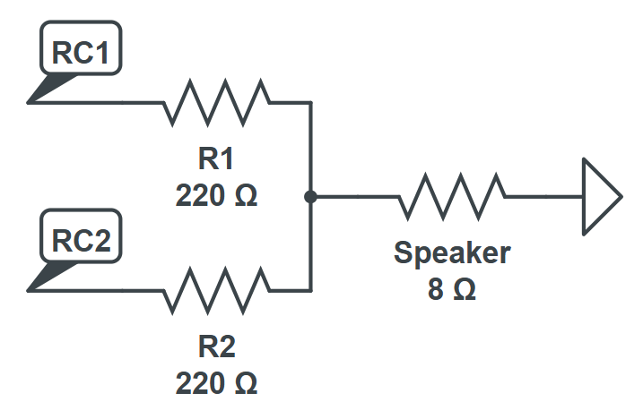 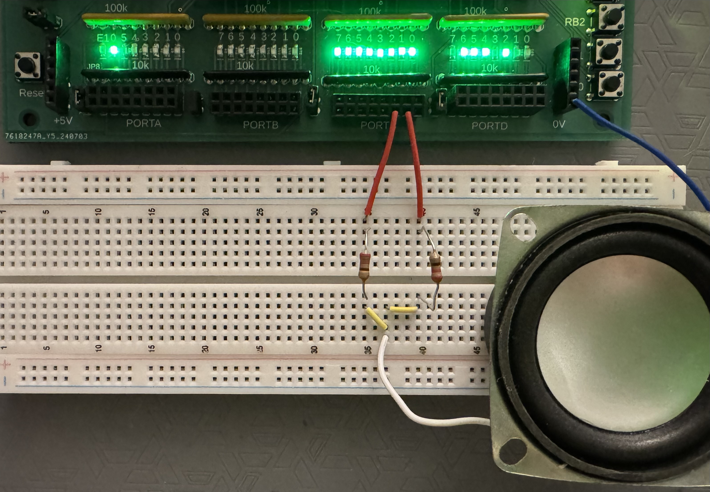

Software Design

C-Code:

#include <pic18.h>

#include "lcd_portd.c"

#define WORLD_SIZE 16

#define DINO_POS 0 // Dino always on the left

// Game variables

unsigned char world[WORLD_SIZE];

unsigned char is_jumping = 0;

unsigned char jump_timer = 0;

unsigned int wait_time = 300; // starting frame delay

unsigned int time_between_speed_increase = 3000;

unsigned char last_was_cactus = 0;

unsigned char game_running = 0;

unsigned char score = 0;

unsigned int seconds = 0;

unsigned char step = 0;

unsigned long T2 = 0; // ms counter (Timer2 interrupt)

unsigned int HIT;

unsigned int tone_time;

const unsigned int C5 = 9556; // jump tone

const unsigned int G3 = 25510; // game-over tone

const unsigned char MSG0[20] = " GAME OVER ";

const unsigned char MSG1[20] = "SCORE: ";

const unsigned char MSG2[20] = "TIME: ";

const unsigned char MSG3[20] = " DINO GAME ";

// Custom characters

const unsigned char DINO[8] = {

0b00111,

0b00101,

0b00111,

0b10110,

0b11111,

0b11110,

0b01110,

0b00110

};

const unsigned char CACTUS[8] = {

0b00100,

0b00101,

0b00101,

0b10110,

0b10100,

0b01100,

0b00100,

0b00100

};

// Custom characters

const unsigned char DINORUNNINGL[8] = {

0b00111,

0b00101,

0b00111,

0b10110,

0b11111,

0b11110,

0b01110,

0b01000

};

// Custom characters

const unsigned char DINORUNNINGR[8] = {

0b00111,

0b00101,

0b00111,

0b10110,

0b11111,

0b11110,

0b01110,

0b00010

};

// Write custom character to CGRAM

void LCD_CustomChar(unsigned char loc, const unsigned char *p)

{

unsigned char i;

LCD_Inst(0x40 + (loc * 8));

for (i = 0; i < 8; i++)

LCD_Write(p[i]);

}

// Reset world: fill with spaces

void init_world() {

unsigned char i;

for(i=0; i<WORLD_SIZE; i++)

world[i] = 32; // spaces only

}

// Scroll world left

void scroll_world() {

unsigned char i;

// Shift left

for(i = 0; i < WORLD_SIZE - 1; i++)

world[i] = world[i+1];

// --- RANDOM CACTUS GENERATION (prevent two in a row) -------

if(last_was_cactus == 0 && (rand() % 4 == 0)) {

world[WORLD_SIZE - 1] = 1; // cactus

last_was_cactus = 1;

}

else {

world[WORLD_SIZE - 1] = 32; // empty

last_was_cactus = 0;

}

}

void shift_right(){

unsigned char i;

// Shift right

for(i = WORLD_SIZE -1; i > 0; i--)

world[i] = world[i-1];

}

// Handle jump input

void jump() {

if(is_jumping) return;

is_jumping = 1;

jump_timer = 2;

}

// Update jump state each frame

void update_jump() {

if(is_jumping) {

if(jump_timer > 0)

jump_timer--;

else

is_jumping = 0;

}

}

// Draw world to LCD

void display_world() {

unsigned char i;

LCD_Move(0,10);

LCD_Out(score,5,0);

// TOP ROW (Dino only if jumping)

for(i=0; i<WORLD_SIZE - 5; i++) {

LCD_Move(0, i);

if(is_jumping && i == DINO_POS)

LCD_Write(0);

else

LCD_Write(32);

}

// BOTTOM ROW (ground + Dino)

for(i=0; i<WORLD_SIZE; i++) {

LCD_Move(1, i);

if(!is_jumping && i == DINO_POS){

LCD_Write(step ? 3 : 2); // alternate legs

}else

LCD_Write(world[i]);

}

step = !step;

}

void display_opening_animation() {

LCD_Inst(1); // clear screen

unsigned char i;

LCD_Move(0,0);

for (i=0; i<20; i++) {

LCD_Write(MSG3[i]); //display title

}

for(i = 0; i < WORLD_SIZE; i++) {

// Draw Dino on top row at position i

LCD_Move(1, i);

LCD_Write(2); // Dino character

Wait_ms(400);

LCD_Move(1,i);

LCD_Write(3);

Wait_ms(200); // adjust speed of animation

LCD_Move(1,i);

LCD_Write(32);

}

}

// Update speed every 1 second

void update_speed() {

if(T2 >= time_between_speed_increase) { // 3000 ms = 3 second

if(wait_time > 30) // don't go too fast

wait_time -= 10;

time_between_speed_increase = time_between_speed_increase + 3000;

}

Wait_ms(wait_time);

}

unsigned char check_collision() {

if(!is_jumping && world[DINO_POS] == 1)

return 1; // HIT!

return 0; // safe

}

void end_game(){

seconds = T2 / 100;

HIT = 1; // trigger game-over tone in Timer3 Interrupt while writing game over

LCD_Inst(1);

LCD_Move(0,0);

unsigned int i;

for (i=0; i<20; i++) {

LCD_Write(MSG0[i]); //display game over

}

HIT = 0;

Wait_ms(100);

HIT = 1;

Wait_ms(50);

HIT = 0;

Wait_ms(1000);

LCD_Inst(1);

LCD_Move(0,0);

for (i=0; i<20; i++) {

LCD_Write(MSG1[i]); //display score

}

LCD_Move(0,10);

LCD_Out(score, 5, 0);

LCD_Move(1,0);

for (i=0; i<20; i++) {

LCD_Write(MSG2[i]); //display time

}

Wait_ms(100);

LCD_Move(1,10);

LCD_Out(seconds, 5, 0);

HIT = 0;

game_running = 0;

T2 = 0;

score = 0;

while(!RB0);

init_world();

is_jumping = 0;

jump_timer = 0;

wait_time = 300;

last_was_cactus = 0;

T2 = 0;

game_running = 1;

}

// Interrupts

void interrupt IntServe(void)

{

if (INT1IF) {

jump();

INT1IF = 0;

}

if (TMR1IF) {

// output start/jump tone when player starts game or jumps (presses RB1)

TMR1 = -C5;

if (RB1) RC1 = !RC1;

TMR1IF = 0;

}

if (TMR2IF) {

T2++; // count milliseconds

TMR2IF = 0;

}

if (TMR3IF) {

TMR3 = -G3;

if (HIT) RC2 = !RC2;

TMR3IF = 0;

}

}

void main(void)

{

TRISA = 0;

TRISB = 0xFF; // input buttons

TRISC = 0;

TRISD = 0;

TRISE = 0;

ADCON1 = 0x0F;

// set up Timer1 for PS = 1

TMR1CS = 0;

T1CON = 0x81;

TMR1ON = 1;

TMR1IE = 1;

TMR1IP = 1;

PEIE = 1;

// Timer2: 1ms overflow

T2CON = 0x4D;

PR2 = 249;

TMR2IE = 1;

TMR2IP = 1;

// set up Timer3 for PS = 1

TMR3CS = 0;

T3CON = 0x81;

TMR3ON = 1;

TMR3IE = 1;

TMR3IP = 1;

PEIE = 1;

// Enable INT1 (RB1)

INT1IE = 1;

TRISB1 = 1;

INTEDG1 = 1;

PEIE = 1;

GIE = 1;

LCD_Inst(0x0C);

LCD_CustomChar(0, DINO);

LCD_CustomChar(1, CACTUS);

LCD_CustomChar(2, DINORUNNINGL);

LCD_CustomChar(3, DINORUNNINGR);

display_opening_animation();

init_world();

display_world();

T2 = 0;

is_jumping = 0;

jump_timer = 0;

wait_time = 300;

game_running = 1;

HIT = 0;

while(1){

while(game_running){

scroll_world();

update_jump();

display_world();

if(check_collision()){

end_game();

}

if(world[DINO_POS] == 1 && is_jumping) {

score++; // Dino safely passed a cactus

}

update_speed();

}

}

}

Compile Results:

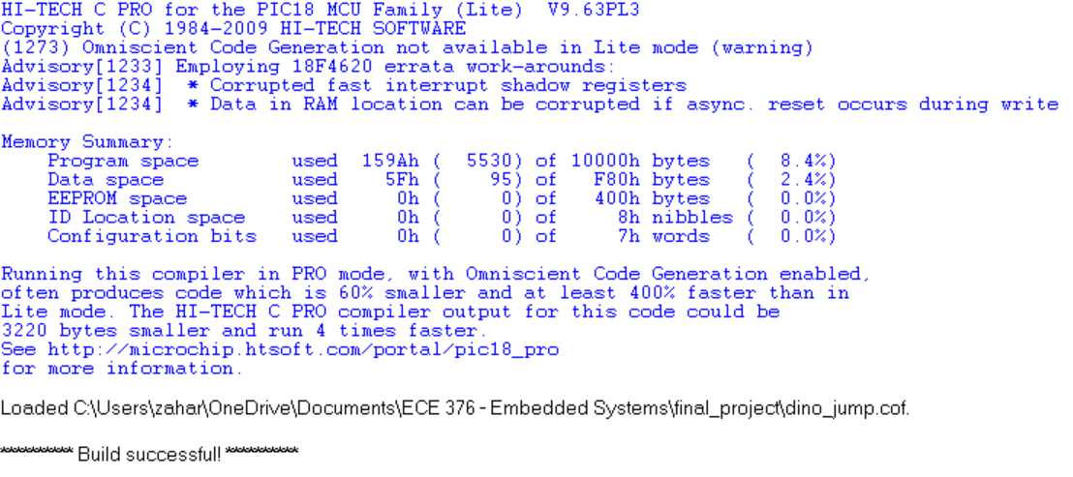

Flow Chart

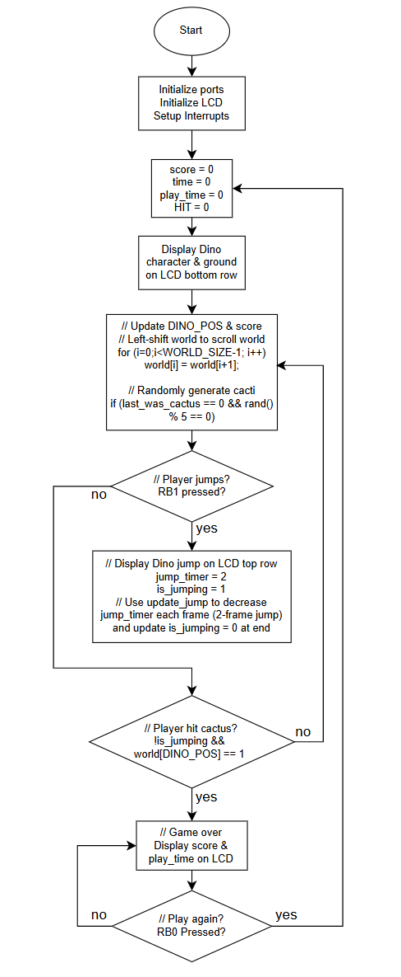

#### Testing

Hardware

* LCD Display shows dinosaur character at lower-left and ground across bottom (verified)
* LCD Display shows cacti which scroll from lower right to left (verified)
  + Cacti are randomly generated and not immediately in succession (verified)
  + After 3 seconds, scroll speed gradually increases (verified)
* RB0 press starts new game (verified)
* RB1 press triggers 2-frame dinosaur character jump (verified)
  + Speaker plays note C5 when RB1 pressed (verified)
* LCD Display shows player score and play-time when player loses (verified)
  + Speaker plays note G5 when score and play-time are displayed (verified)

Interrupts

* INT1 interrupt tracks RB1 button press (verified)
* Timer1 interrupt triggers note C5 via RC1 on RB1 button press (verified)
* Timer2 interrupt tracks time for scroll speed increase & play-time (verified)
* Timer3 interrupt triggers note G5 via RC2 on game-over while stats display (verified)

#### Validation

Requirements Met

* First round starts automatically. Play-time starts tracking when game starts. (verified)
* LCD Display shows player avatar (dinosaur) on lower left side of the screen. (verified)
* Randomly generated cacti scroll across the screen from right to left). (verified)
  + At least 1 space between each cactus (verified)
  + Scroll speed gradually increases (verified)
* RB1 works for player jump. (verified)
  + Jump tone plays via speaker when player presses RB1/jumps (verified)
  + Player gets 1 point for every cactus they successfully pass (verified)
* Player loses if they hit a cactus. (verified)
  + Play-time stops tracking when player hits a cactus (verified)
  + LCD Display shows player stats (verified)
  + Game-over tone plays twice via speaker as stats are displayed (verified)
* RB0 works to play again. (verified)
  + Score, play-time, game variables, and LCD Display reset to starting state (verified)

#### Demo

Video attached to submission separately.